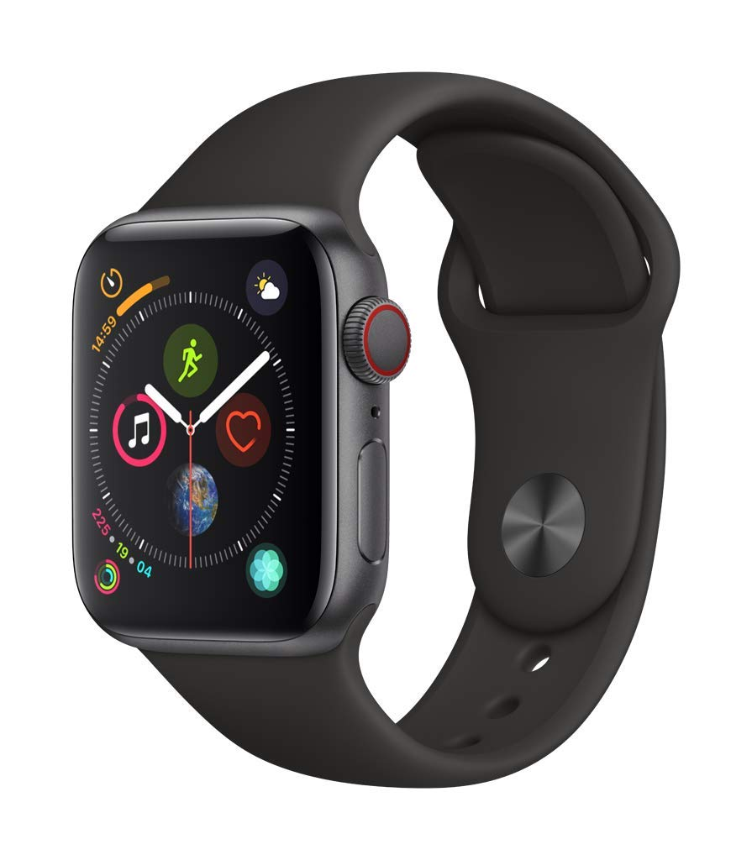

# Apple Watch Series 4 (GPS + Cellular, 40mm) - Space Gray Aluminium Case with Black Sport Band

Gold Aluminum + Pink Sand Sport Band Gold Aluminum + Pink Sand Sport Loop Gold Stanless Steel + Gold Milanese Loop Gold Stanless Steel + Gold Stone Sport B... Silver Aluminum + Seashell Sport Loop Silver Aluminum + White Sport Band Silver Stainless Steel + Silver Milanese... Silver Stainless Steel + White Sport Ban... Space Black Stainless Steel + Black Spor... Space Black Stainless Steel + Space Blac... Space Gray Aluminum + Black Sport Band Space Gray Aluminum + Black Sport Loop Space Gray Aluminum + Black Sport Band

* GPS + Cellular
* Over 30% larger display and 50% louder speaker
* Electrical and optical heart sensors
* Digital Crown with haptic feedback
* 50% louder speaker
* S4 SiP with faster 64-bit dual-core processor
* Improved accelerometer and gyroscope for fall detection
* Swim proof
* watch OS 5
* Aluminum or stainless steel case

Source:

<https://www.amazon.com/dp/B07K3835BD?aaxitk=gVOBud.p0mx8I7zvk17jlQ&pd_rd_i=B07K3835BD&pf_rd_p=e037c154-e093-48a4-b127-477e5e294e3f&hsa_cr_id=9044222990901&sb-ci-n=productDescription&sb-ci-v=Apple%C2%A0Watch%20Series%C2%A04%20(GPS%C2%A0%2B%C2%A0Cellular%2C%2040mm)%20-%20Space%20Gray%20Aluminium%20Case%20with%20Black%20Sport%20Band>

Note: This item does not ship to **Korea; Republic of (South Korea)**.

Dear Guys,

I was googling if there is any way/application used to sent the health info like heartbeat from apple smartwatch to computers, and I found the following. It used message to sent the health information and I hope helps in some way to get heartbeat information from smartwatch.

We need to make this message to be sent to the paired device in some time interval even though live transmission is different.

<https://theappfactor.com/how-to-export-health-app-data-iphone-ipad/>

<https://www.macobserver.com/tips/quick-tip/ios-and-watchos-historical-heart-rate-data/>

<https://9to5mac.com/2018/12/06/share-ecg-results-with-your-doctor/>

<https://discussions.apple.com/thread/8235416>